Urban Farming
  - A local response to a global situation
Authored by: Craig Crosthwaite (Foodbank Coordinator)

Why Urban Farming?

Achieving food security, eliminating hunger, and removing poverty have been among important foci of the Agenda 21 (UN, 1992), Millennium Development Goals (UN,
2000), and the Sustainable Development Goals (UN 2015a,b). While there are strong criticisms of broad-brushed initiatives (Horton 2014), these are generic guidelines at
all levels of governance. Yet, the insidious problem of food and nutritional insecurity plagues humanity even more now than ever before. While the number of food-insecure
population has progressively decreased since 1990s, there remain some 795 million food-insecure people (FAO, 2015a; Fig. 1) and an additional ~2 billion are prone to hidden hunger or malnutrition caused by the deficiency of micronutrients and protein (Ruel-Bergeron et al. 2015).

The Food Ethics Council states “Food poverty means that an individual or household isn’t able to obtain healthy, nutritious food, or can’t access the food they would like to eat. Despite increasing choice and affordability of food in the UK, many people eat what they can afford, not what they want.

This often results in people eating poor diets, which can lead to heart disease, obesity, diabetes and cancer, as well as inadequate levels of many vitamins and minerals. Obesity is now as much a sign of poverty in the rich countries, as hunger is in poor countries.
Food poverty and economic poverty are linked. Rent, tax and debts are fixed costs; food is the ‘flexible’ budget item, and families and individuals pay the price.
Poor children suffer from lower nutrient intake, bad dietary patterns, hunger, low fruit and vegetable consumption and problems accessing food in school holidays.
A 2014 report by Oxfam UK, the Trussell Trust and Church Action on Poverty revealed that over 20 million meals were provided in 2013 to people in the UK who could not afford to feed themselves - a 54% increase on the previous 12 months. An estimated 4.7 million people were living in severely food insecure homes in 2014, according to the FAO.
We know from many official sources and the work of the charitable sector that many people within our own community’s face food insecurity. The reasons falling within those suggested above. North Ayrshire is not immune to this world-wide phenomenon and becoming part of the global Urban Farming movement will assist in addressing this issue.

What is Urban Farming

Simply put, urban farming is growing or producing food in a city or heavily populated town or municipality.

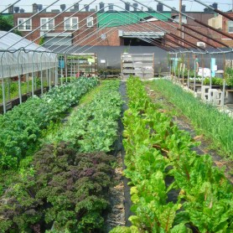
Urban farming consists of the for-profit (Urban agriculture) and the not-for-profit (community gardening or subsistence farming) sectors. Urban agriculture assumes a level of commerce, the growing of product to be sold as opposed to being grown for personal consumption or sharing as it is in community gardening where there is no such commercial activity.

You do not need to be a corporation to be an urban farm or have a large tract of land. An individual, a couple of friends, a nonprofit entity, or neighbourhood group can start and run an urban farm.

The for-profit urban farm may sell to restaurants or at a farmers market with some given to a local soup kitchen or church, but the food is raised primarily to be moved (through some form of commerce) from the grower to the user.

Urban agriculture has become a means to increase access to locally grown food and a way of reintroducing the public to the many aspects of food that we have lost as a culture. How food grows, what grows regionally and seasonally are all important lessons and make a better informed urban consumer.

For some the term urban implies inner city. For others, urban has come to mean areas that are on the perimeter of cities (what some refer to as peri-urban). There is no single characterization of size or placement; some are on rooftops, on landfills or brownfields, areas where housing or industry may have been demolished. Some cities are giving up part of their park systems to allow urban farmers to plant their seeds.

Most not-for-profit urban farms are built exclusively for education, training or re-entry to employment programmes. Many are built to improve food access in a specific community where food justice is a concern and creating means to improving the access to fresh food for economically disadvantaged communities is the priority.
(- See more at: http://www.greensgrow.org/urban-farm/what-is-urban-farming/#sthash.m0R17951.dpuf

Is Urban Farming Productive?

The Food and Agriculture Organization (FAO) of the United Nations reports that 800 million people worldwide grow vegetables or fruits or raise animals in cities, producing an astonishing 15 to 20 percent of the world’s food.
As cities grow and social security nets diminish the need for more projects to develop Urban Farms will increase.

Elizabeth Royte notes in her article on Urban farms that:

*Despite their relatively small size, urban farms grow a surprising amount of food, with yields that often surpass those of their rural cousins.
*They can also plant more densely because they hand cultivate, nourish their soil more frequently and micromanage applications of water and fertilizer.
*producing far more food and feeding more people, in aggregate, than their commercial counterparts.
*Funders don’t necessarily expect community gardens to become self-sustaining (Maybe just in the US?).
*Critics say about Urban Farms “And it’s completely inefficient, economically. Urban farmers can’t charge what they should, and they’re too small to take advantage of economies of scale and use their resources more efficiently.”
*However, supporters note: “That doesn’t mean that community gardeners, who don’t even try to be profitable, aren’t making a big difference in their immediate communities. Camden’s 31,000 pounds (14,000 kg) of produce might not seem like a lot, but it’s a very big deal for those lucky enough to get their hands on it.

The competition for space for the developing cities as well as a string of environmental concerns – fertilizers, water contamination, deforestation, desserts, climate change, bio-diversity issues – means that the development of urban farms will play a critical role in redressing these pressures.

Where can Urban Farming happen?

The beauty of Urban farming is that it can take place anywhere. Modern technologies mean that plants can be grown in plant pots, raised flower beds, derelict pieces of ground (with good sunshine), unused grass areas, brownfield sites, old industrial units, shipping containers and on roof-tops as well as the external walls of buildings.

Rattan Lal states in his report that the goal is to reconcile high production with better environmental quality, develop urban agriculture (aquaponics, aeroponics, and vertical farms), promote nutrition-sensitive farming, and restore degraded soils.
(Feeding 11 billion on 0.5 billion hectare of area under cereal crops
Rattan Lal - Carbon Management and Sequestration Center, The Ohio State University, Columbus, Ohio 43210)

This can be achieved as technologies improve and the reliance on pesticides is reduced.

Wikipedia records “Urban agriculture, urban farming or urban gardening is the practice of cultivating, processing, and distributing food in or around a village, town, or city.^{[1]} Urban agriculture can also involve animal husbandry, aquaculture, agroforestry, urban beekeeping, and horticulture.
These activities occur in peri-urban areas as well, and peri-urban agriculture may have different characteristics.^{[2]}
Urban agriculture can reflect varying levels of economic and social development. In the global north, it often takes the form of a social movement for sustainable communities, where organic growers, ‘foodies,’ and ‘locavores’ form social networks founded on a shared ethos of nature and community holism. These networks can evolve when receiving formal institutional support, becoming integrated into local town planning as a ‘transition town’ movement for sustainable urban development. In the developing south, food security, nutrition, and income generation are key motivations for the practice. In either case, more direct access to fresh vegetables, fruits, and meat products through urban agriculture can improve food security and food safety.

Noting the above definition and the corresponding policy framework to address food poverty in North Ayrshire Urban farming can happen and is happening here within our own communities. The 3 Town Growers have been extremely active as have those at Eglington, Fairlie, West Kilbride and in the Garnock Valley.

More can be done using the underutilised spaces within our communities as noted at the beginning of this section and the North Ayrshire Foodbank and 3 Towns Growers aspire to see Ardrossan become a food town providing an environment whereby residents are in and amongst nature which provides food as well as an aesthetically pleasing location.

Urban Farming approaches.

Allotment gardens are the most popular for individuals to get exercise and grow healthy and nutritional fruit, vegetables and herbs. These are generally for personal consumption and raised flowers beds are in high demand. Whilst beneficial to individuals and families they can be supplemented with other approaches which may have wider social impact by being accessible by all and in need as well as avoiding the use of land.

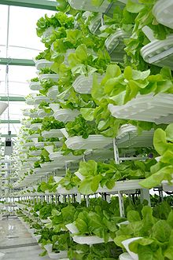
A roof garden is a garden on the roof of a building. Besides the decorative benefit, roof plantings may provide food, temperature control, hydrological benefits, architectural enhancement, habitats or corridors^{[1]} for wildlife, recreational opportunities, and in large scale it may even have ecological benefits. The practice of cultivating food on the rooftop of buildings is sometimes referred to as rooftop farming.^{[2]} Rooftop farming is usually done using green roof, hydroponics, aeroponics or air-dynaponics systems or container gardens.^{[3]}

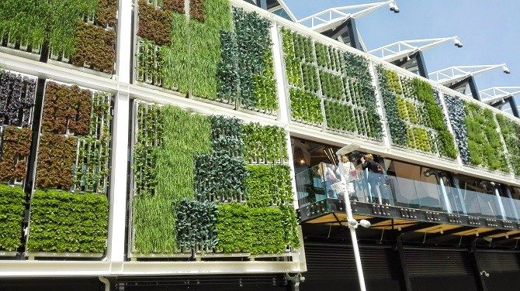
Vertical farming is the practice of producing food in vertically stacked layers, such as in a skyscraper, used warehouse, or shipping container. The modern ideas of vertical farming use indoor farming techniques and controlled-environment agriculture (CEA) technology, where all environmental factors can be controlled. These facilities utilize artificial control of light, environmental control (humidity, temperature, gases...) and fertigation. Some vertical farms use techniques similar to greenhouses, where natural sunlight can be augmented with artificial lighting and metal reflectors.^{[1][2][3]}

(Growng on the outside of a building).
Urban farming approaches

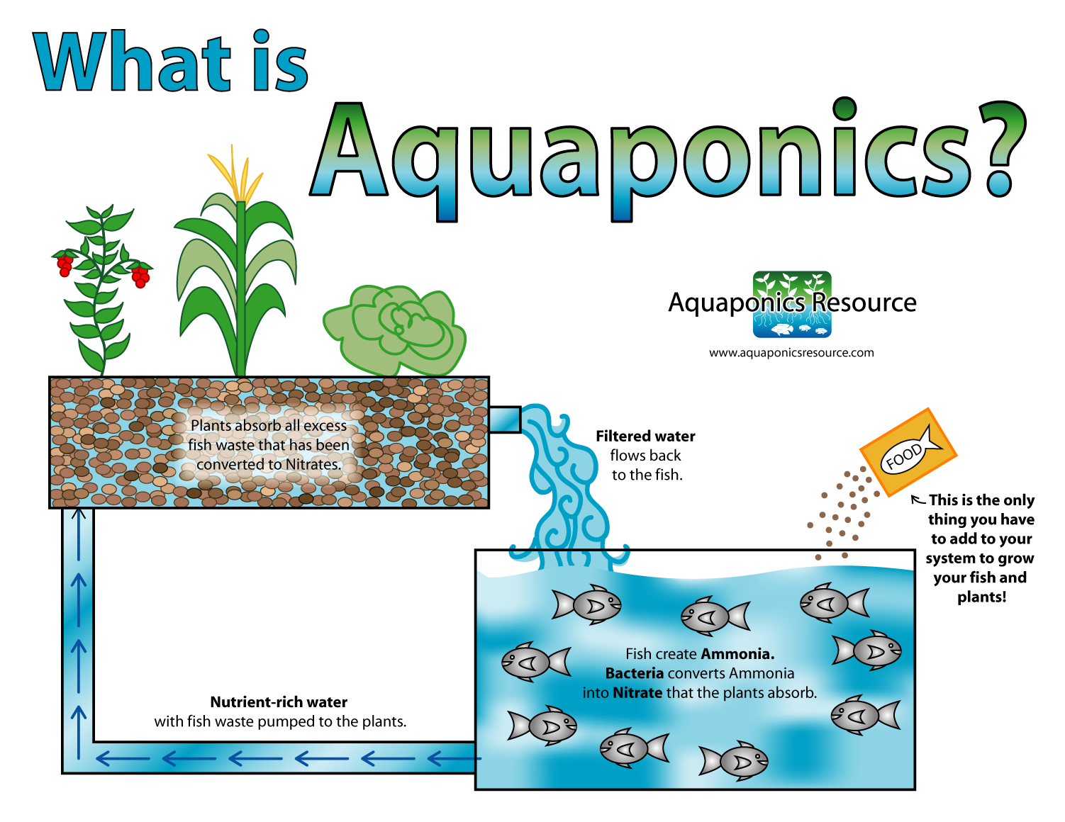
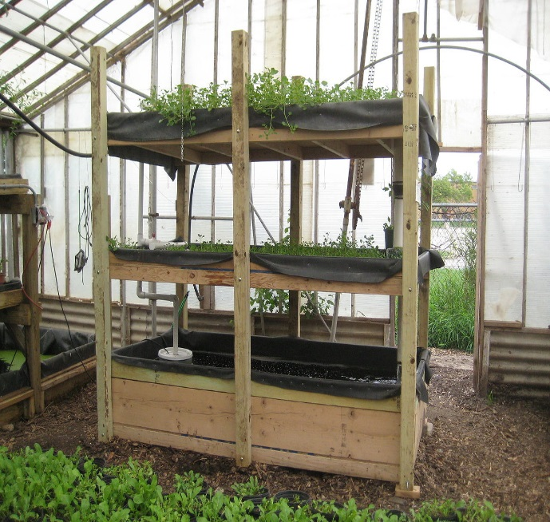
Aquaponics (/ˈækwəˈpɒnᵻks/) refers to any system that combines conventional aquaculture (raising aquatic animals such as snails, fish, crayfish or prawns in tanks) with hydroponics (cultivating plants in water) in a symbiotic environment. In normal aquaculture, excretions from the animals being raised can accumulate in the water, increasing toxicity. In an aquaponic system, water from an aquaculture system is fed to a hydroponic system where the by-products are broken down by nitrifying bacteria initially into nitrites and subsequently into nitrates, which are utilized by the plants as nutrients, and the water is then recirculated back to the aquaculture system.

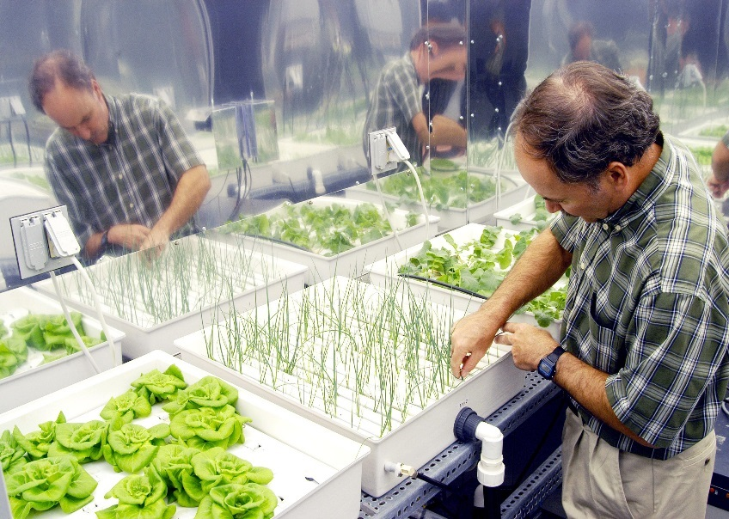
Hydroponics is a subset of hydroculture, the method of growing plants without soil, using mineral nutrient solutions in a water solvent.^{[1]} Terrestrial plants may be grown with only their roots exposed to the mineral solution, or the roots may be supported by an inert medium, such as perlite or gravel. The nutrients in hydroponics can be from fish waste, duck manure, or normal nutrients.

Conclusion.

The report “How to feed the world in 2050” states that “By 2050 the world’s population will reach 9.1 billion, 34 percent higher than today. Nearly all of this population increase will occur in developing countries. Urbanization will continue at an accelerated pace, and about 70 percent of the world’s population will be urban (compared to 49 percent today). Income levels will be many multiples of what they are now. In order to feed this larger, more urban and richer population, food production (net of food used for biofuels) must increase by 70 percent. Annual cereal production will need to rise to about 3 billion tonnes from 2.1 billion today and annual meat production will need to rise by
over 200 million tonnes to reach 470 million tonnes.

This report argues that the required increase in food production can be achieved if the
necessary investment is undertaken and policies conducive to agricultural production are put in place. But increasing production is not sufficient to achieve food security. It must be complemented by policies to enhance access by fighting poverty, especially in rural areas, as well as effective safety net programmes”.

North Ayrshire, as we know from Local Authority Services and Third sector organisations, is not immune to food poverty amongst our neighbours and friends. Whilst it is not caused by under-production of food it is caused by the withdrawal of the safety net programmes (welfare support), lack of employment and limited incomes to afford adequate food.

By creating a food town, using all the space we can spare, we can bring our communities back into harmony with nature, access its bounty and provide access to nutritional and healthy fruit, vegetables and herbs with the attending benefits of health and wellbeing and reducing if not eliminating hunger.

