APPENDIX:
Ardrossan gets its fair share of weather that may be detrimental to the production of vegetables, fruits and herbs. In carrying out this very basic desktop research several images have caught the authors attention and may provide examples of approaches and technologies that could enhance the production of food. These are only notes.
UNDERGROUND GREENHOUSE
http://www.realworldsurvivor.com/2013/10/28/underground-greenhouses/#geogreenhouse2
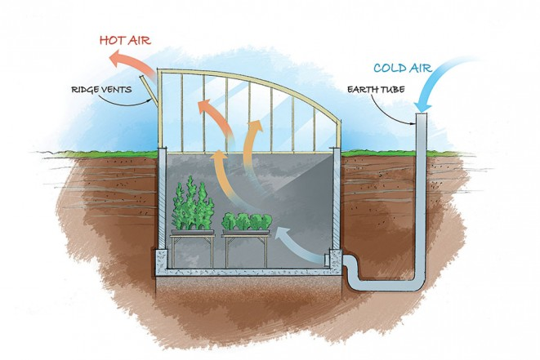
EDEN PROJECT
http://www.edenproject.com/#RJobr3QTVtTfjLvl.97
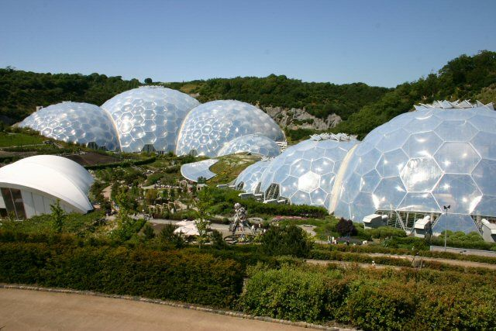

Disney Hydroponics (EPCOT)
http://www.simply-hydroponics.com/96/hydroponics-at-walt-disney-world-mickey-mouse-pumpkins/

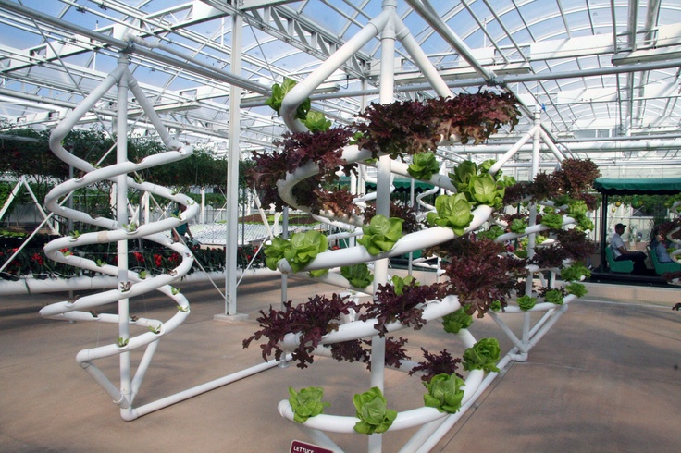

Vertical farming (Outdoors)
http://www.nbcnews.com/id/21154137/ns/technology_and_science-innovation/t/could-vertical-farming-be-future/#.WQeqIlXyuUk
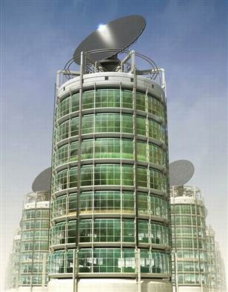

Vertical Farming (Indoors)
http://scienceofthetime.com/2011/05/27/vertical-farming/

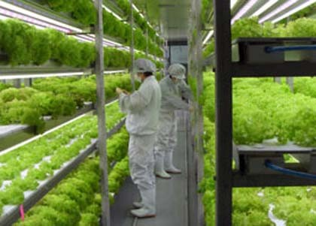

Rooftop
http://www.telegraph.co.uk/environment/

